LAB Logbook

Lab 1
Code:
vector = np.arange(1,99)
vector = vector.reshape(1,vector.size)
print(vector)
newVector = vector
print(newVector)
print(newVector.shape)
Result:
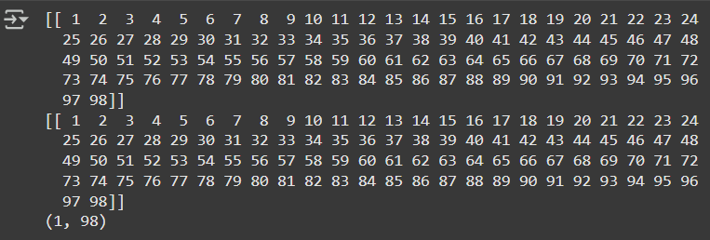

Lab 2

Lab 3

Lab 4

Lab 5

Lab 6

Lab 7

Lab 8

Lab 9

Lab 10

Lab 11

Lab 12

